**<b>Project background</b>**

Lead is one of persistent toxic substances (PTS), and lead pollution is typical heavy metal pollution in soil environment. Stable lead ions in soil can accumulate through crops, and finally enter human body, causing great impact on the ecosystem and human health.[1]

（土壤→作物→人体的图）

The Institute for Health Metrics and Evaluation (IHME) estimated that, in 2017, lead exposure accounted for 1.06 million deaths and 24.4 million years of healthy life lost (disability-adjusted life years (DALYs)) worldwide due to long-term effects on health. The IHME also estimated that, in 2016, lead exposure accounted for 63.2% of the global burden of idiopathic developmental intellectual disability, 10.3% of the global burden of hypertensive heart disease, 5.6% of the global burden of the ischaemic heart disease and 6.2% of the global burden of stroke.[2]

**<b>Current situation</b>**

Up to now, <b>no proper treatment methods have been developed for moderately lead-polluted cultivated lands, which are still playing a productive role. </b> The crops produced in these lands will also pose a threat to people’s health and safety.

However, considering the cultivated lands that still give full play to its production performance, current methods such as the combination of physicochemical immobilization with phytoremediation and the microbial adsorption may still have some limitations:[3,4]

* Disturbance caused by physicochemical immobilization with foreign fixing agents to the original physicochemical property of soil environment.
* Negative impacts on production efficiency brought by planting a large number of lead-enriched plants
* Low efficiency due to the complicated distribution of heavy metal in soil environment
* Difficulty in ensuring the survival rate of microorganisms

物理化学固铅配合植物修复的图

微生物吸附的图

To transcend limitations imposed by current methods, our team attempted to re-consider this problem with a hope to add a new approach to treatment of soil lead pollution.

**<b>Our inspiration</b>**

At this point, we were inspired by the research on lead immobilization. Lead in soil can form <b> exceptionally stable pyromorphite

[Pb<sub>5</sub>(PO<sub>4</sub>)<sub>3</sub>X (X = Cl, F, OH)]</b> in the presence of enough soluble phosphate with a K<sub>sp</sub>of about 10<sup>-60</sup> — 10<sup>-80</sup>. [5] It has passed the EPA standard of the United States, and it’s described to be unable to extract effective lead through the TCLP method.

This research enlightened us to form an idea: transforming lead ions into such a stable mineral.

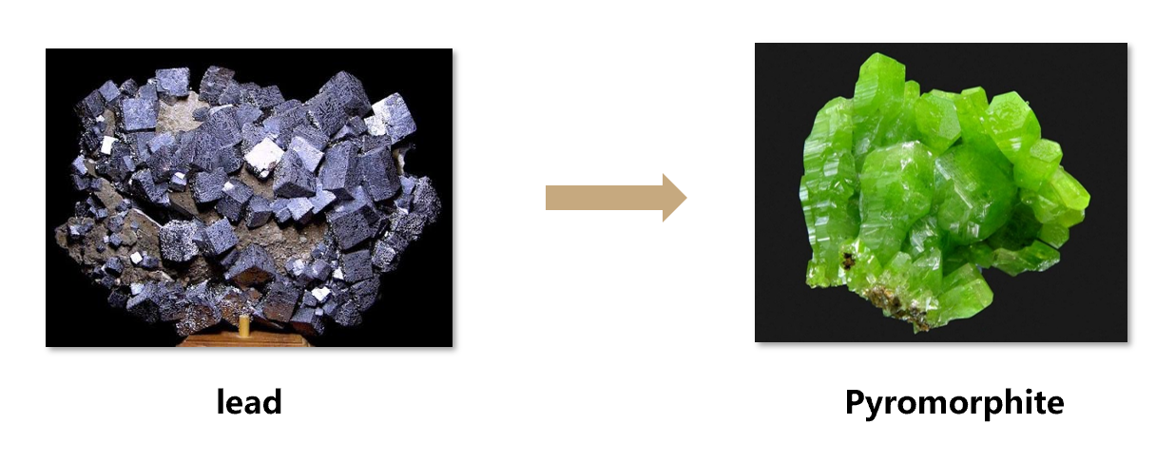

图要改

**<b>Two essentials </b>**

The main component of the pyromorphite crystal is phosphate PO<sub>4</sub><sup>3-</sup>, but most phosphorus in the soil is insoluble. In the meanwhile, the complex soil environment, leads to relatively dispersed heavy metals

So，in order to achieve our goal, we need to get two essentials prepared:

* <b>a significant amount of soluble phosphate
* a certain way to relatively accumulate the heavy metal lead </b>

Native phosphorus-solubilizing microorganisms in the soil and native earthworms provide us with great help.

Soil phosphorus-soluble microorganisms can convert insoluble phosphorus from soil to soluble phosphorus by secreting phosphorus-soluble enzymes and organic acids.[6]

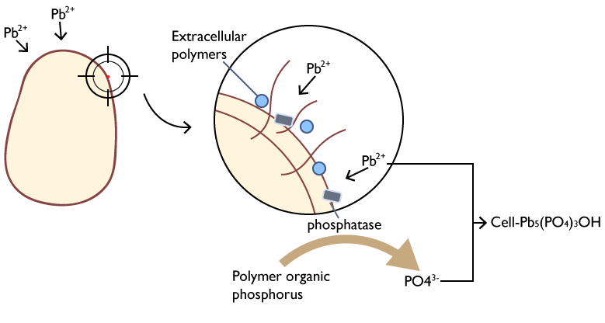

解磷微生物功能概念图

As an indigenous worm in the soil, earthworms have certain tolerance and enrichment ability to heavy metals. [7 ] Therefore, earthworms can be ideal helpers：

* Earthworms can live in the soil polluted by heavy metals and accumulate heavy metal ions in their bodies.
* The intestinal tract of earthworm can be a good culture medium for our selected engineering bacteria.[8]

蚯蚓富集重金属的图

流程图(放在网页右侧，文字左侧环绕)

**<b>Our strategy</b>**

<b>Our project plans to employ earthworms as a mobile carrier for heavy metal treatment, and use <i>*bacillus subtilis*</i>, the dominant symbiotic bacterium in earthworm intestine, as an engineering bacterium to achieve the enrichment and fixation process of heavy metals.</b> Earthworms can accumulate lead ions in soil by intaking the soil, and we use the toehold switch based on the oxygen-regulated switch in d<i>*Bacillus subtilis*</i>.

As a result, the engineered bacteria can secrete phytase in the earthworms’ intestines, which has similar function with phosphatase, and therefore release the phosphorus element in the soil eaten by earthworms. together with organic acid, the metabolite of <i>*Bacillus subtilis*</i> itself, the soluble phosphate, lead ions working together to form pyromorphite in the intestines of earthworms and complete the fixation of lead. Finally, the pyromorphite is discharged with earthworm intestinal excrement, along with the engineered bacteria into the external aerobic environment. Under the joint action of oxygen limit switch and Toehold switch, the suicide module of the engineered bacteria is triggered, thus guaranteeing the biosafety of our project.

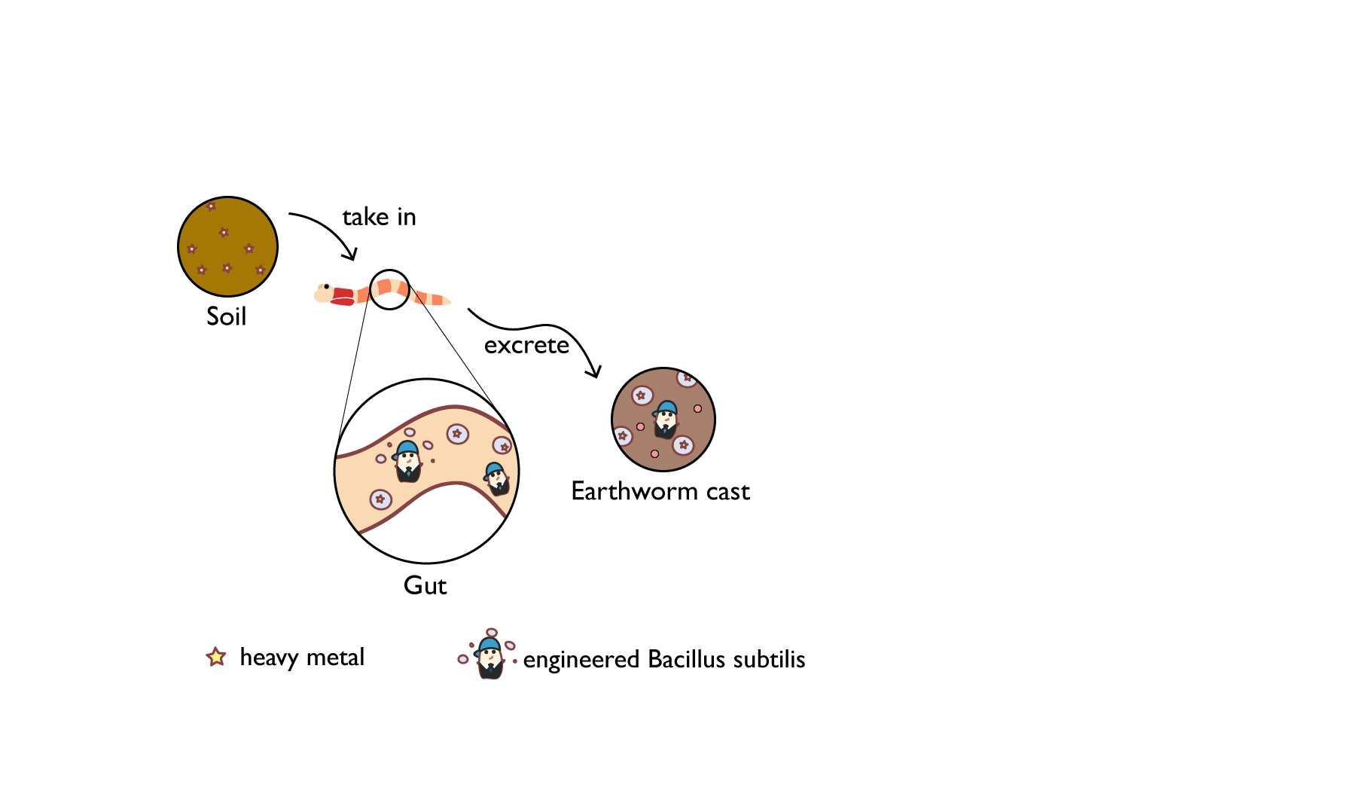

图要改，最终表现为蚯蚓摄食土壤富集重金属，并通过工程菌在肠道内形成焦晶岩,并体现出最终工程菌的自杀）

In this year, due to isolation caused by COVID-19, we are unable to do our wet lab experiments. We verify our concept based on literature and we employ mathematical models to predict results and feasibility.

1. Teng, Z.; Shao, W.; Zhang, K.; Yu, F.;  Huo, Y.; Li, M., Enhanced passivation of lead with immobilized phosphate solubilizing bacteria beads loaded with biochar/ nanoscale zero valent iron composite. J Hazard Mater 2020, 384, 121505.
2. Institute for Health Metrics and Evaluation (IHME). GBD Compare. Seattle, WA: IHME, University of Washington; 2017.
3. Chen Weijie. Research on the Challenges and Countermeasures of Heavy Metal Pollution Control in Farmland Soils in China[J]. Environment and Development,2020,32(04):67-68.
4. Wang Jing, Yin Guoxun. Research status and existing problems of phytoremediation of contaminated soil[J]. Guangdong Chemical Industry,2010,37(01):82-83+97.
5. Chen H, Zhang J, Tang L, Su M, Tian D, Zhang L, et al. Enhanced Pb immobilization via the combination of biochar and phosphate solubilizing bacteria. Environ Int. 2019; 127:395-401.
6. Xu JC, Huang LM, Chen C, Wang J, Long XX. Effective lead immobilization by phosphate rock solubilization mediated by phosphate rock amendment and phosphate solubilizing bacteria. Chemosphere. 2019;237:124540.
7. Zhang, K., et al., Lead removal by phosphate solubilizing bacteria isolated from soil through biomineralization. Chemosphere, 2019. 224: p. 272-279.
8. Cao Jia, Wang Chong, Huang Yan, Ji Dingge, Journal of Applied Ecology Lou J. Research progress on the effects of earthworms on soil microbes and biological fertility. 2015(05): 294-301.
9. Wang Na. Research progress in the application of earthworms and their metabolites in the remediation of heavy metal contaminated soils[J]. Modern Agricultural Science and Technology, 2018, 000(022):184-185,191.